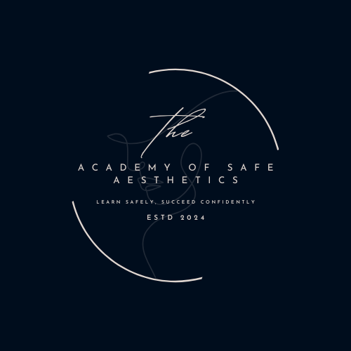

Anti-Bullying and Harassment Policy

The Academy of Safe Aesthetics is committed to creating and maintaining a learning environment that is free from bullying, harassment, discrimination, or any other form of inappropriate behavior. All trainers, trainees, staff, and visitors have the right to feel safe, respected, and valued at all times. Bullying and harassment of any kind, whether physical, verbal, or psychological, will not be tolerated. This policy outlines the academy’s commitment to preventing and addressing bullying and harassment in all its forms.
Scope
This policy applies to all trainers, trainees, staff, and visitors associated with The Academy of Safe Aesthetics during any training sessions, events, or activities, both in person and online. It includes all forms of bullying and harassment, including but not limited to: physical, verbal, cyber, racial, sexual, and emotional abuse.
Definition of Bullying and Harassment
- Bullying is repeated, unwanted, and intentional behavior that is intended to hurt, intimidate, or belittle another person. It can take various forms, including but not limited to:
  - Physical bullying (e.g., pushing, hitting, or damaging personal property)
  - Verbal bullying (e.g., name-calling, mocking, insults)
  - Social bullying (e.g., excluding others, spreading rumors)
  - Cyberbullying (e.g., using digital platforms to harm or intimidate others)
- Harassment is any behavior that creates a hostile or intimidating environment, or that causes distress to the individual. It includes actions that target someone based on characteristics such as race, gender, sexual orientation, disability, age, or any other personal characteristic. Examples of harassment include:
  - Unwelcome sexual advances or comments
  - Discriminatory jokes or remarks based on race, religion, or other personal characteristics

  - Offensive gestures or visual representations (e.g., inappropriate images, text messages, or social media posts)
  - Making someone feel threatened, humiliated, or degraded based on their appearance, abilities, or beliefs

Key Principles
- Respect for All Individuals
We value a diverse and inclusive learning environment where everyone is treated with dignity and respect. All individuals at [Academy Name] are expected to act in a manner that promotes mutual respect, kindness, and understanding.
- Zero Tolerance for Bullying and Harassment
Bullying and harassment are strictly prohibited in all forms. We will not tolerate any behavior that makes others feel unsafe or unwelcome.
- Supportive Environment
Everyone has a responsibility to contribute to a safe, inclusive, and supportive environment. Students, instructors, and staff must be proactive in recognizing and addressing any signs of bullying or harassment.
- Confidentiality and Support
All complaints or concerns regarding bullying and harassment will be treated with the utmost confidentiality. The academy will provide support to anyone who has been affected by such behavior, and individuals are encouraged to come forward without fear of retaliation.

Responsibilities
- Students’ Responsibilities
  - Treat all classmates, instructors, and staff with respect and dignity.
  - Do not engage in or condone any form of bullying or harassment.
  - Report any instances of bullying or harassment immediately to an instructor or academy staff.

  - Support peers who may be experiencing bullying or harassment by standing up for them and helping them report incidents.
- Instructors’ Responsibilities
  - Foster a safe and respectful learning environment in all training settings.
  - Address any signs of bullying or harassment promptly and appropriately.
  - Support students who report bullying or harassment, and provide resources or counseling where necessary.
  - Ensure that all students are aware of the academy’s Anti-Bullying and Harassment Policy.
  - Report any serious incidents of bullying or harassment to academy management.
- Academy Staff and Management Responsibilities
  - Implement and enforce the Anti-Bullying and Harassment Policy throughout the academy.
  - Investigate all reported incidents of bullying or harassment fairly and promptly.
  - Provide a clear and transparent process for reporting incidents and ensuring that any consequences are consistent and fair.
  - Support individuals affected by bullying or harassment, providing access to counseling or other resources as needed.
Reporting Procedures
If you experience or witness bullying or harassment at [Academy Name], we encourage you to report it as soon as possible. There are several ways to report incidents:
- Speak directly to your instructor or any other trusted member of staff.
- Submit a formal report via the academy’s reporting system (e.g., email, online form).
- Contact Academy Management if the matter is not resolved or if you are uncomfortable discussing the issue with your instructor.
All complaints will be handled confidentially, and the academy will take appropriate action based on the nature and severity of the incident. Individuals who report in good faith will be protected from retaliation.
Investigation and Consequences
- Investigation
  - All reported incidents of bullying or harassment will be thoroughly investigated in a fair and impartial manner.

  - The individual making the report, as well as the person accused of bullying or harassment, will have the opportunity to provide information during the investigation.
  - The academy may consult relevant policies, documentation, and witnesses to determine the facts of the case.
- Consequences
  - If the investigation confirms that bullying or harassment has occurred, appropriate disciplinary action will be taken. Consequences may include:
    - A formal warning
    - Suspension or expulsion from the academy
    - Removal of privileges or certification (in cases of serious misconduct)
    - Referral to appropriate authorities (in cases of illegal behavior, such as assault or threats)
Prevention and Awareness
To help prevent bullying and harassment, The Academy of Safe Aesthetics will:
- Conduct training sessions for students and staff on recognizing and addressing bullying and harassment.
- Promote an inclusive and supportive learning environment through regular activities and discussions.
- Encourage open communication and provide accessible resources for anyone in need of support.
Conclusion
The Academy of Safe Aesthetics is committed to ensuring that bullying and harassment are not tolerated and that every individual can learn and work in an environment free from fear or discrimination. All students, instructors, and staff play a critical role in fostering a safe and respectful community. By adhering to this policy, we can ensure that The Academy of Safe Aesthetics remains a positive, professional, and inclusive place for everyone.

Review date: 28/02/2026

