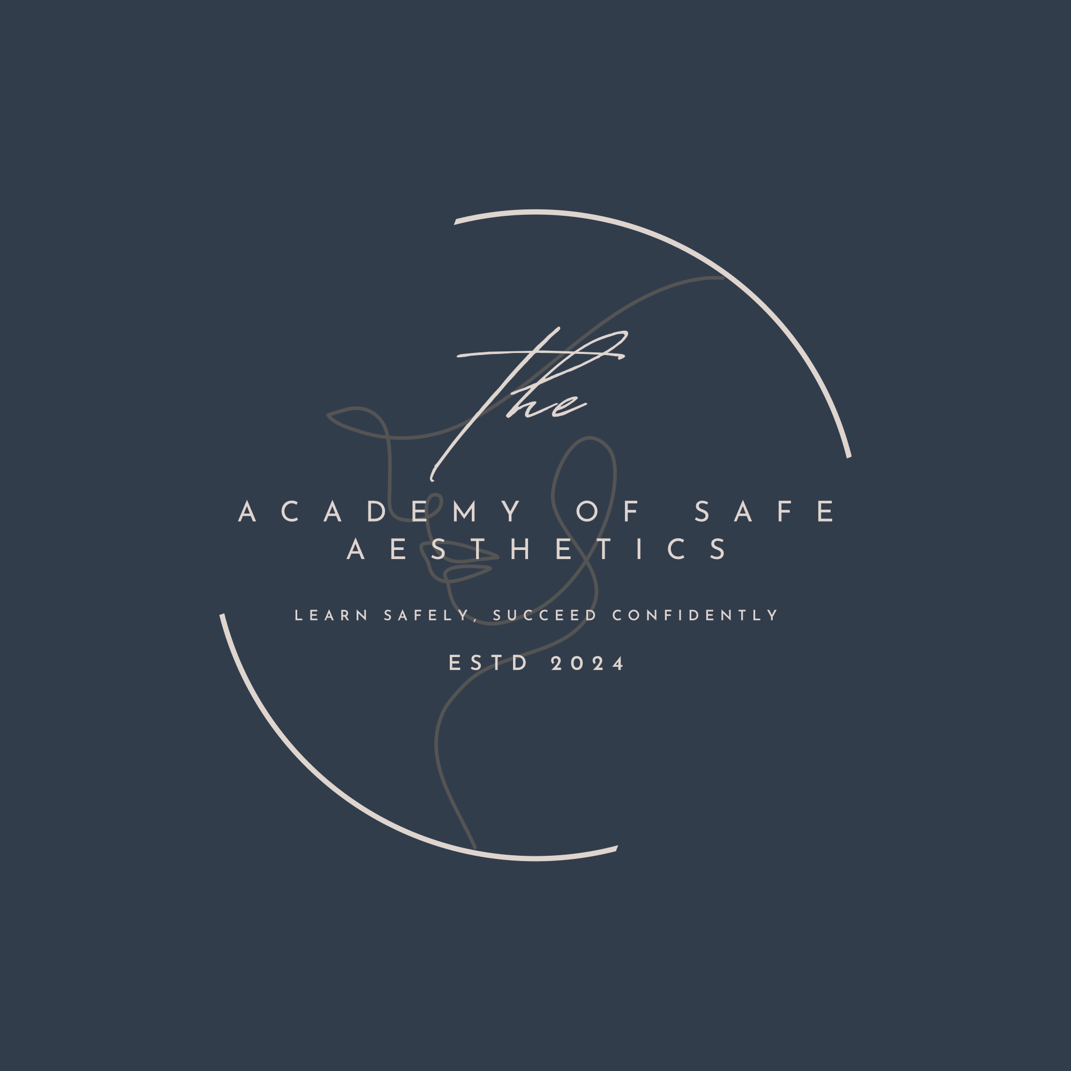

Cookies Policy

The Academy of Safe Aesthetics ("us", "we", or "our") uses cookies on our website and our associated domains (see note) (the "Service"). By using the Service, you consent to the use of cookies. Our Cookies Policy explains what cookies are, how we use cookies, how third-parties we may partner with may use cookies on the Service, your choices regarding cookies and further information about cookies.

What are cookies

Cookies are small pieces of text sent by your web browser by a website you visit. A cookie file is stored in your web browser and allows the Service or a third-party to recognise you and make your next visit easier and the Service more useful to you. Cookies can be "persistent" or "session" cookies.

How The Academy of Safe Aesthetics uses cookies

When you use and access the Service, we may place a number of cookies files in your web browser. We use cookies for the following purposes: to enable certain functions of the Service and to provide analytics. We use both session and persistent cookies on the Service and we use different types of cookies to run the Service:

- Essential cookies. We may use essential cookies to authenticate users and prevent
fraudulent use of user accounts.

Third-party cookies

In addition to our own cookies, we may also use various third-parties’ cookies to report usage statistics of the Service.

What are your choices regarding cookies

If you'd like to delete cookies or instruct your web browser to delete or refuse cookies, please visit the help pages of your web browser. Please note, however, that if you delete cookies or refuse to accept them, you might not be able to use all of the features we offer, you may not be able to store your preferences, and some of our pages might not display properly.

Where can you find more information about cookies

You can learn more about cookies and the following third-party websites:

- All About Cookies: http://www.allaboutcookies.org/
- Network Advertising Initiative: http://www.networkadvertising.org/

