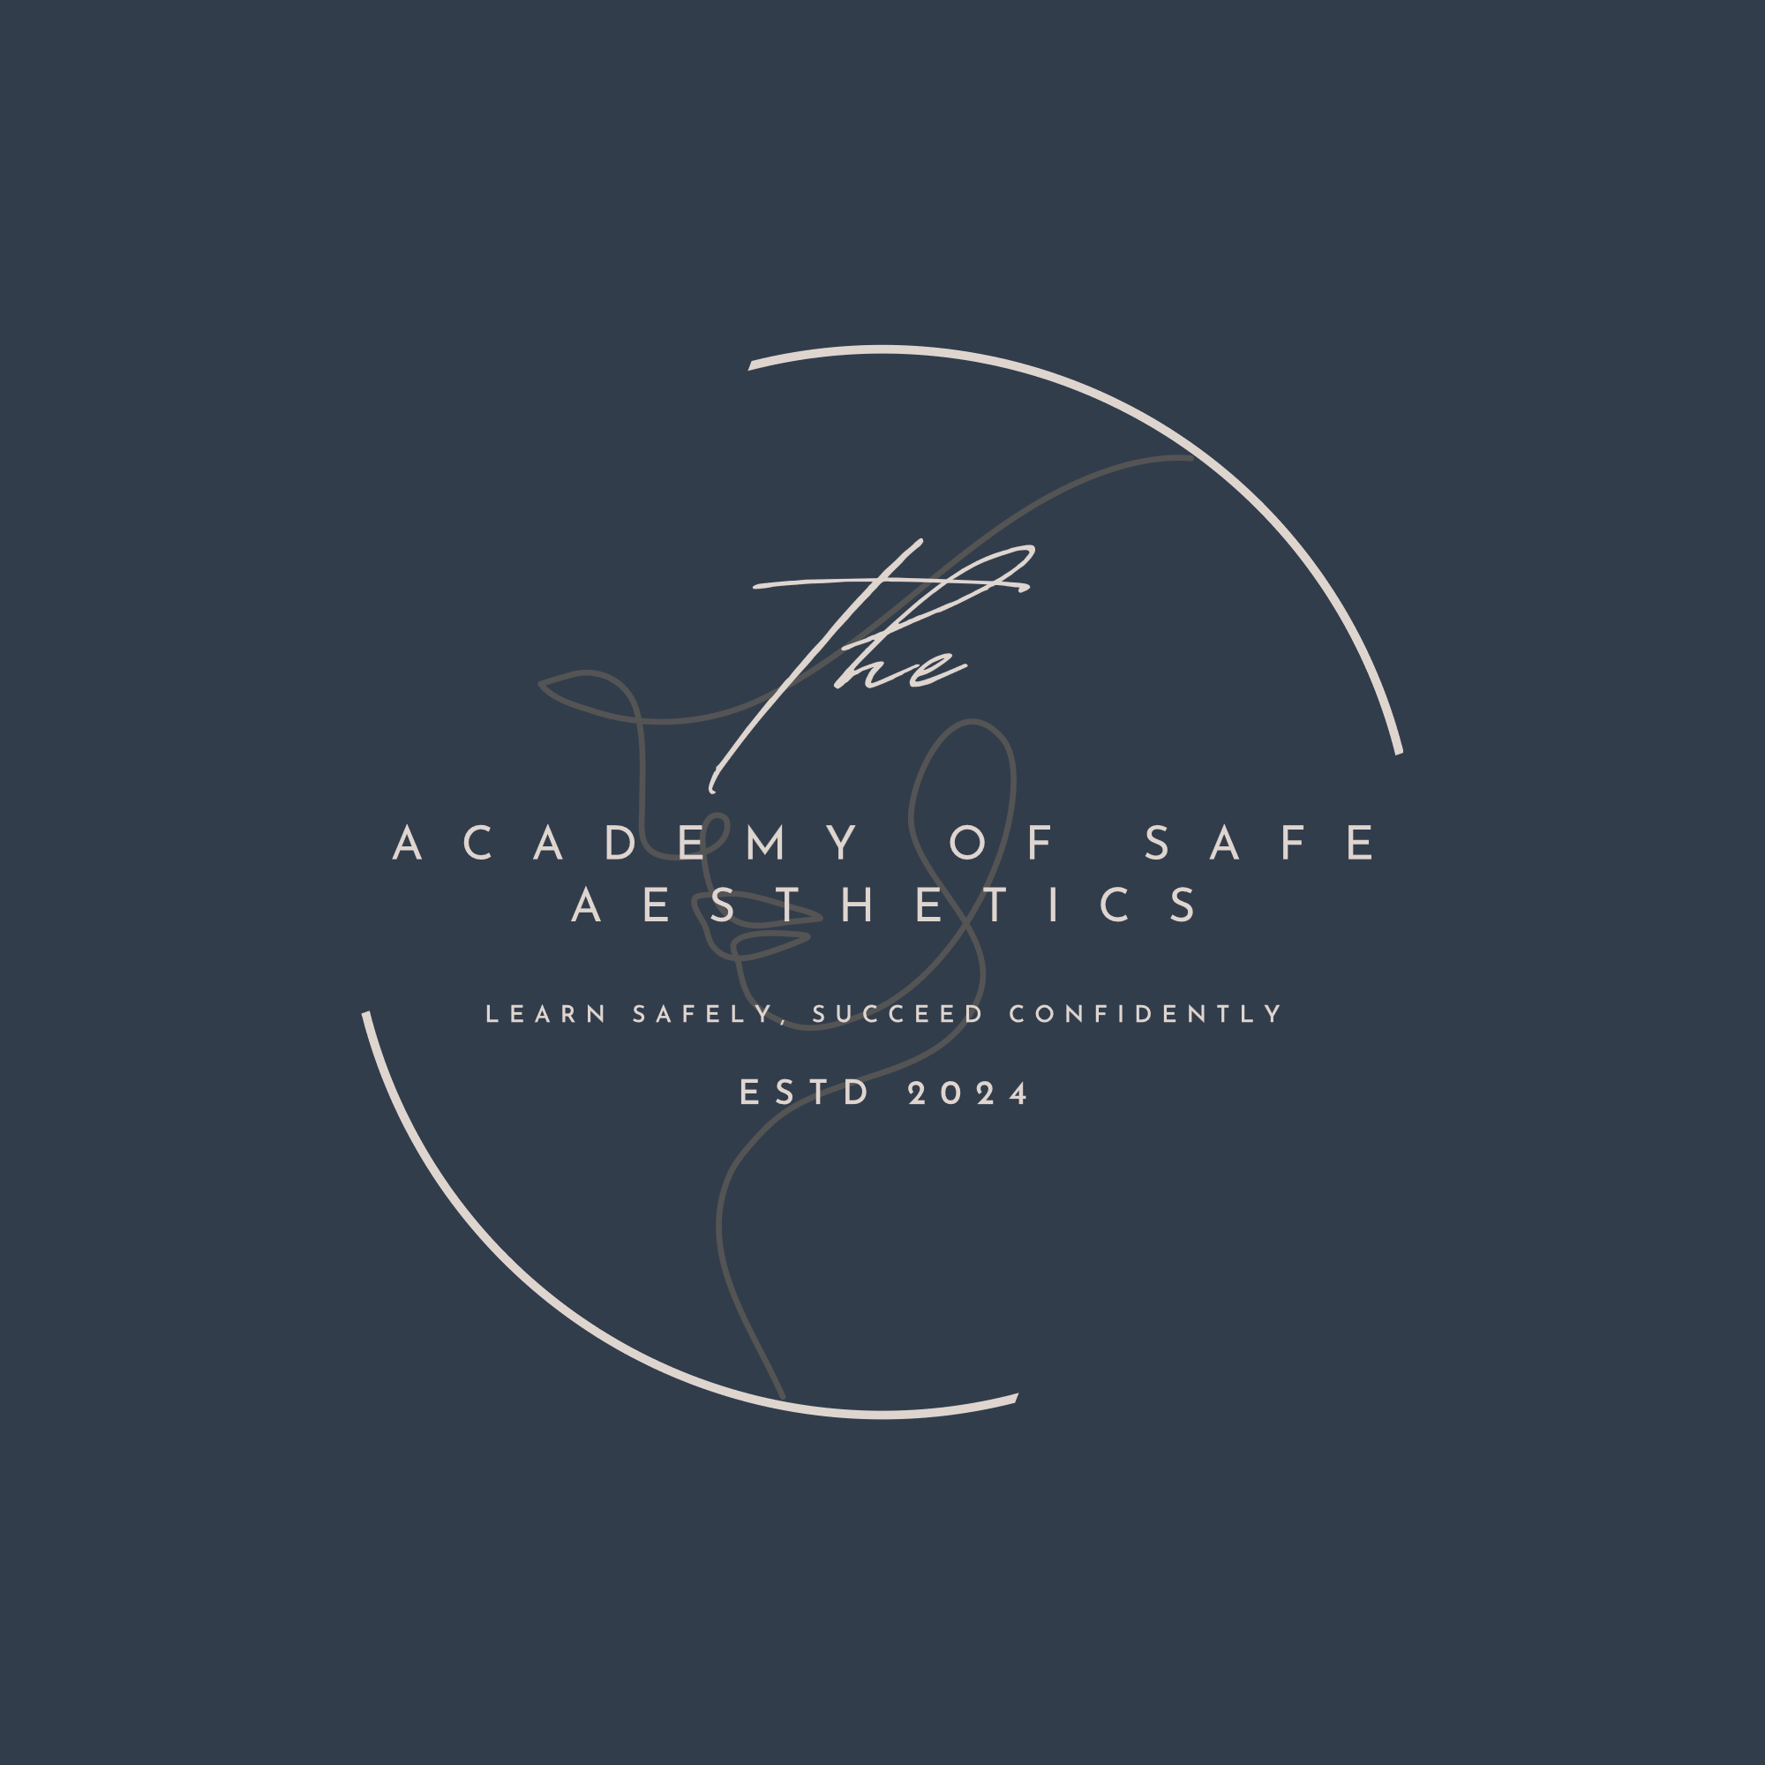

Plagiarism Policy

As an organisation that carries out assessments, The Academy of Safe Aesthetics has an obligation to Examination and/or Awarding Bodies, its learners, employers and society in general to ensure that the qualifications its learners achieve are a fair and accurate representation of their work, and of the knowledge and skills they have attained during the course of their studies with the The Academy of Safe Aesthetics

Plagiarism and other forms of cheating, undermine the value of a qualification for all concerned as it undermines its credibility. If a learner passes an assessment, or attains a qualification, by unfair means then this is unfair to those who have achieved the same qualification fairly. For these reasons the The Academy of Safe Aesthetics will take all appropriate measures to ensure that learners work is in fact their own, and that plagiarism and other forms of cheating have not taken place. The Centre will also take appropriate action where plagiarism is detected.

Plagiarism

Plagiarism is a form of cheating and has been described as ‘a practice that involves knowingly taking and using another person’s work and claiming it, directly or indirectly, as your own’.

The above definition of plagiarism covers a range of degrees of seriousness and intent. For example, learners can be motivated by laziness as well as by a direct intent to obtain a qualification unfairly. In practice, it can also be difficult to distinguish between where plagiarism has taken place deliberately and where there has been a failure to acknowledge sources of information appropriately. There is a clear difference of degree between poor referencing of a quotation and the deliberate passing off of an entire piece of work with the intention of obtaining a qualification unfairly. It should be noted, however, that whether it is intentional or not, plagiarism presents a problem when it interferes with the accurate assessment of a learner’s ability.

Plagiarism can also be seen as a breach of trust between tutors and their learners, and between society and its members, and as such issues relating to plagiarism are matters of honesty and fairness.

The Academy of Safe Aesthetics Policy

The Academy of Safe Aesthetics is fully committed to the detection of plagiarism and in taking appropriate measures in its detection, which include:

- The implementation of electronic means of detecting plagiarism.
- Training its tutors/staff in plagiarism prevention and detection.
- Informing all its learners of the Centre’s position on plagiarism and of the methods being used to aid detection of plagiarism.
- Instilling in its learners an ethos of fairness and appropriate reward for effort expended.
- The promotion of effective assessment design and assessment practice.
- Ensuring that learners are properly instructed in what constitutes fair practice and appropriate referencing.
- Taking disciplinary action as and when appropriate

Responsibility

It is the responsibility of all The Academy of Safe Aesthetics learners and tutors to ensure that the learner work submitted for purposes of assessment is their own work. It is the responsibility of all
The Academy of Safe Aesthetics learners:

- To ensure that work submitted for purposes of assessment is their own.
- To ensure that the words and arguments of others are appropriately cited and referenced using an accepted referencing system, in the case of the The Academy of Safe Aesthetics this is the Harvard system of referencing.

Learners must not simply copy materials from other learners, past or present, from written sources, from the Internet, or from any other source whether this is through cutting and pasting, rewriting or by any other means. Changing a few words within a copied piece of text does not render the work as original and still amounts to plagiarism. In short, work submitted by learners must be their own unless it is specifically indicated within the text through appropriate referencing that this is not the case – or where originality was clearly not a requirement of the assessment being undertaken.

It is the responsibility of all The Academy of Safe Aesthetics tutors:

- To regularly stress to their learners of the unethical nature of plagiarism.
- To make clear to their learners the Centre’s policy on plagiarism and the consequences if they fail to comply.
- To ensure that their learners have the knowledge and skills required to enable them to cite and reference appropriately.

It is also the responsibility of all The Academy of Safe Aesthetics tutors to take all possible measures to ensure that when plagiarism does occur it is detected, and appropriate action is taken – see The Academy of Safe Aesthetics plagiarism procedure. Evidence of plagiarism should be carefully gathered and retained. Issues relating to plagiarism by an individual learner or learners are confidential matters and should be treated as such. All records should be kept with due concern for confidentiality and the need for evidence.

In the first instance it is the responsibility of the Centre Manager to ensure that records relating to instances of plagiarism are kept for the required length of time for those records. It is the responsibility of the Centre Manager to ensure that these records are appropriately destroyed once the period of time required for their retention has elapsed.

Standards should be applied fairly by all The Academy of Safe Aesthetics tutors so that accusations of unequal treatment cannot be alleged against the Centre and its tutors/staff.

Plagiarism and Quality Improvement

All Centre tutors should also note that learners sometimes copy material word for word not out of a deliberate attempt to cheat. But in some cases, copying of this kind may be a coping strategy for learners and may indicate either that they are on the wrong course/programme or pathway of study which may be too difficult for them, or there may be actual shortcomings in the course/programme or pathway of study itself. While this should not be seen as an excuse for what is still essentially cheating, it may indicate additional action which is required over and above dealing with the instance of plagiarism itself. This action might include study skills guidance/intervention or additional support for the individual learner, or the rethinking of course/programme content. For example, is referencing adequately covered as part of the course/programme, have key concepts been adequately covered, and has the assessment activity been properly explained.

Action Taken and Reporting on the Detection of Plagiarism

All instances of plagiarism, whether they are intentional or not, require action. In all cases, the member of staff must take care to ensure that there is indeed clear evidence that plagiarism has taken place. If plagiarism is detected, then all tutors must refer to The Academy of Safe Aesthetics plagiarism procedure to determine the course of action. The procedure is found on The Academy of Safe Aesthetics website. On detecting plagiarism in learner work the tutor may instigate the implementation of The Academy of Safe Aesthetics plagiarism procedure. In addition, the tutor must also report the alleged plagiarism to the relevant Centre Manager. The tutor will follow the stages The Academy of Safe Aesthetics plagiarism procedure to arrive at a resolution. Once the resolution has been achieved the tutor must inform the relevant Centre Manager.

If for whatever reason the tutor cannot reach a satisfactory resolution then he/she must inform the relevant Centre Manager, who will then aid the tutor in arriving at a satisfactory resolution.

