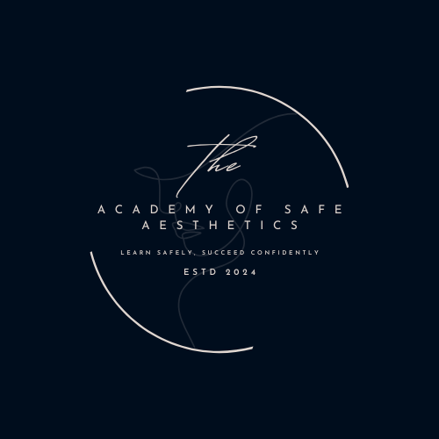
The Academy of Safe Aesthetics Certification and Assessment Policy
Objective:
To ensure clear and consistent guidelines for certification and assessment, ensuring that participants are fairly evaluated and that certification is awarded based on demonstrated competence.

1. Assessment Overview:
- Assessments are designed to evaluate the learner’s understanding of the course material, skills, and practical application.
- The assessment methods may include written tests, practical exercises, case studies, or a combination of these.
- Participants must demonstrate competence to successfully pass the assessment and be awarded certification.
2. Assessment Methods:
- Written Assessments: Multiple-choice questions, short answers, essays, or other written formats may be used to evaluate theoretical understanding.
- Practical Assessments: Participants may be required to demonstrate their skills in practical exercises or simulations relevant to the course content.
- Project Work: Some courses may include project-based assessments, where participants must complete a task or case study.
- Peer Reviews: In some cases, peer review or group assessments may be incorporated.
3. Pass Requirements:
- To successfully complete a course and receive certification, participants must:
  - Meet the minimum pass mark, which will be communicated at the beginning of the course.
  - Demonstrate competence in practical assessments, as determined by the course instructor.
  - If the course includes multiple assessments, participants must pass all components to receive certification.

4. Re-assessment:
- If a participant does not meet the required standards for any assessment, they may be given one opportunity for re-assessment.
- Re-assessments will be scheduled within a reasonable time frame and may incur an additional fee depending on the nature of the assessment.
- For practical assessments, participants may need to repeat specific tasks or exercises.
5. Certification:
- Upon successful completion of the course and assessments, participants will receive a certificate of achievement.
- The certificate will include the learner’s name, course title, date of completion, and any qualifications earned (e.g., CPD points or professional accreditation).
- Certificates are issued only to participants who have met all the requirements outlined in the course.
6. Criteria for Certification:
- Full attendance is a requirement for certification in all courses. If a learner misses any sessions, certification will not be granted.
- If the course is competency-based, learners must demonstrate proficiency in both theoretical and practical aspects of the course to qualify for certification.
7. Validity of Certification:
- Certification is valid for a specified period (if applicable), especially in courses that require updated knowledge or skills
- Some certifications may require ongoing professional development or periodic renewal to maintain validity.
8. Appeals Process:
- Learners who feel they have been unfairly assessed or have not received appropriate feedback may appeal their assessment result.
- Appeals must be submitted in writing within 7 days of receiving the assessment outcome. The appeal will be reviewed by the course instructor or relevant authority, and the outcome will be communicated to the learner within 14 days.

9. Course Completion and Certification Timeframe:
- Upon successful completion, certificates will be issued on the day of assessment results being finalized.
10. Lost or Damaged Certificates:
- If a certificate is lost or damaged, participants can request a replacement for a fee, subject to verification of completion.

Contact Information:
For any questions related to certification, assessment, or appeals, please contact The Academy of Safe Aesthetics
Review date 28/02/2026

