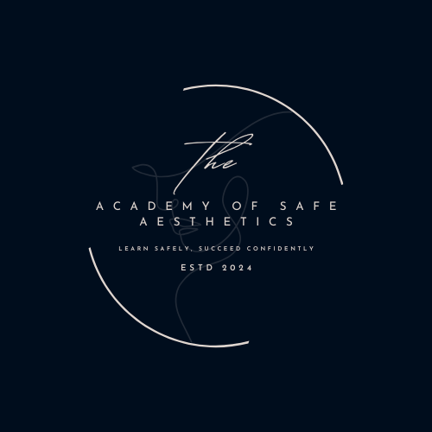
The Academy of Safe Aesthetics
Health and Safety Policy
1. Purpose
The purpose of this Health and Safety Policy is to ensure the health, safety, and welfare of all staff, trainers, trainees, and visitors at The Academy of Safe Aesthetics. This policy outlines our commitment to maintaining a safe and compliant environment in all aspects of our operations.

2. Scope
This policy applies to all staff, trainers, trainees, contractors, and visitors participating in activities, courses, and events conducted by the Academy.

3. Responsibilities
3.1. Management Responsibilities
- Ensure compliance with all relevant health and safety legislation.
- Conduct regular risk assessments and implement necessary control measures.
- Provide adequate resources for health and safety, including training, equipment, and facilities.
- Ensure all incidents are reported, recorded, and investigated promptly.
3.2. Staff and Trainer Responsibilities
- Adhere to all health and safety procedures.
- Report hazards, accidents, or near misses immediately to management.
- Ensure the safe use of equipment, materials, and facilities.
- Attend mandatory health and safety training sessions.

3.3. Student Responsibilities
- Follow all health and safety instructions provided during training.
- Use equipment safely and report any concerns to the trainer or staff.
- Comply with hygiene and infection control procedures.

4. Health and Safety Procedures
4.1. Risk Assessments
- Risk assessments will be conducted regularly for training sessions, premises, and equipment.
- Control measures will be implemented to mitigate identified risks.
4.2. First Aid and Emergency Response
- A designated first aid officer will be present during all training sessions.
- Emergency contact numbers and procedures will be clearly displayed on-site.
4.3. Infection Control
- All equipment and surfaces must be cleaned and disinfected before and after use.
- Students and staff must adhere to hand hygiene and wear appropriate personal protective equipment (PPE).
4.4. Fire Safety
- Fire evacuation procedures will be communicated to all participants.
- Fire exits will remain accessible, and fire drills will be conducted periodically.

5. Incident Reporting and Investigation
- All incidents, accidents, or near misses must be reported immediately to management.
- An incident report form will be completed, and the incident will be investigated to prevent recurrence.

6. Monitoring and Review
- This policy will be reviewed annually or following significant changes in operations or legislation.
- Feedback from staff, trainers, and students will be considered during the review process.

7. Communication and Training
- The Health and Safety Policy will be accessible to all staff, trainers, and students.
- Regular training will be provided to ensure understanding and compliance with health and safety standards.

Signed:
Yvette Iskandarani Reem Marstani

Directors, The Academy of Safe Aesthetics
Date:
Review date: 28/02/2025

